Task on Autoscaling Groups.
- Create one vpc in N.virginia region.
Created one vpc in Tokyo region , because on N ,VIRGINAE another user
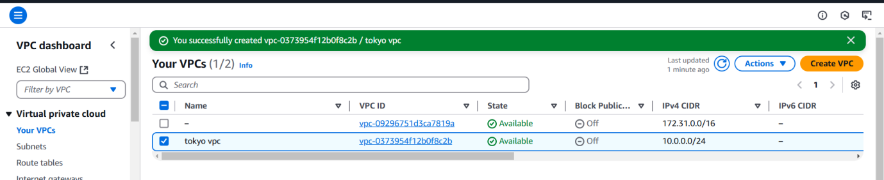
2) Create two subnets.
One Public subnet and one private subnet.
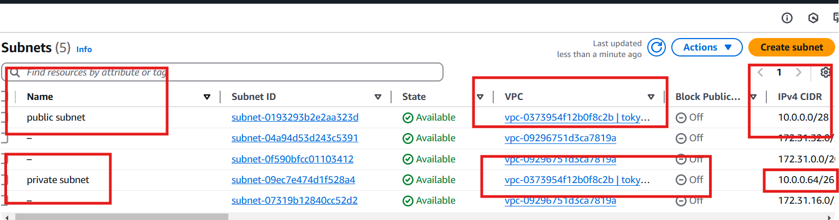
3) Provide the IGW and attach to the vpc.
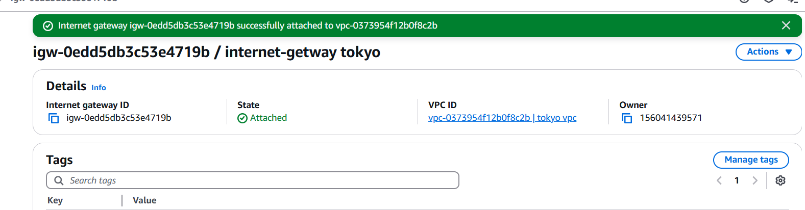

4) Create One public RT and one private RT.
Step
Rename one public route to newly created vpc TOKYO, and created one private route table
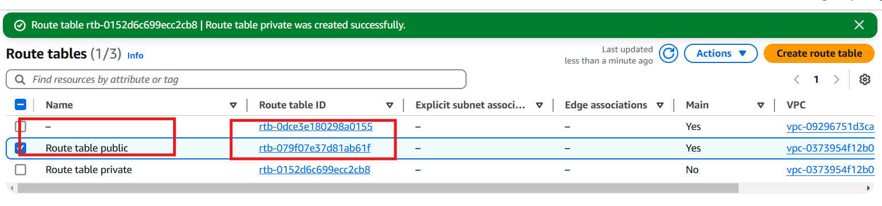
Step 2 add internet gate way to public route table and edit routes
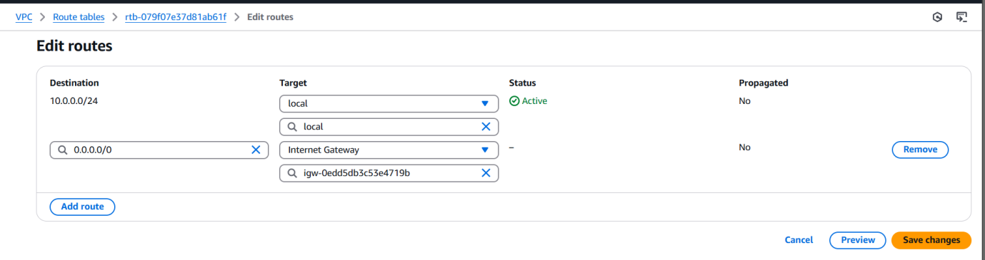
Step 3 edit subnet association for public route table
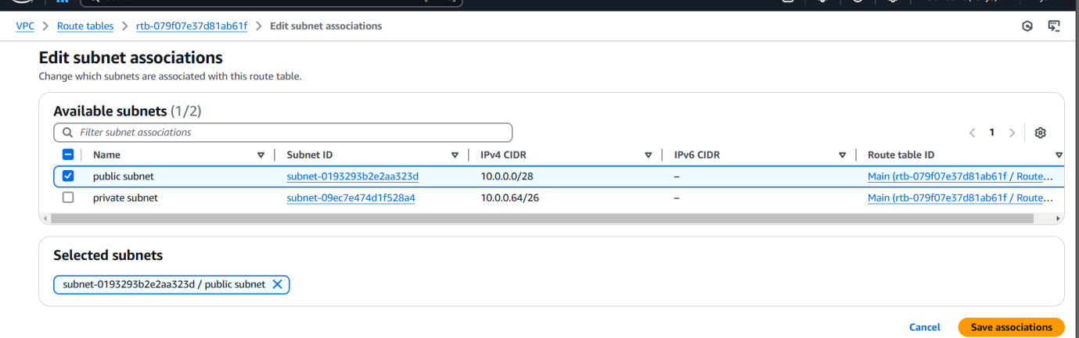
Step 4 edit subnet association for private route table

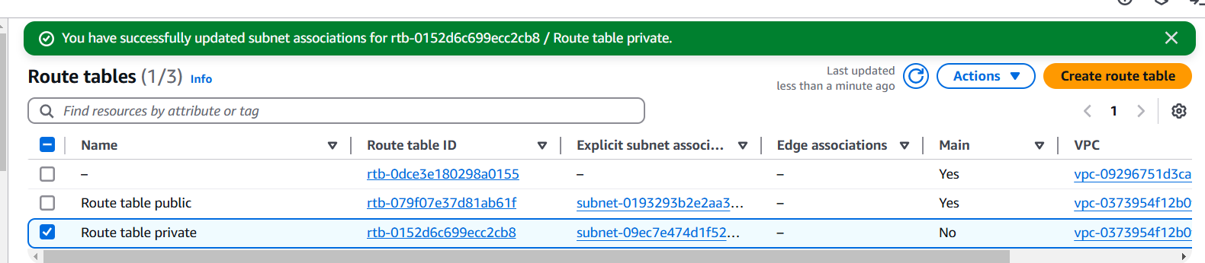
5) Deploy NAT gateway on public subnet and attach the NAT gatewat to private subnet.
Step 1: Go create NATgateway and allocate one elastic ip to and select private subnet 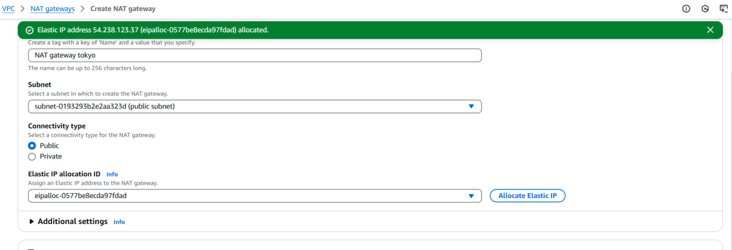


NAT GATEWAY created
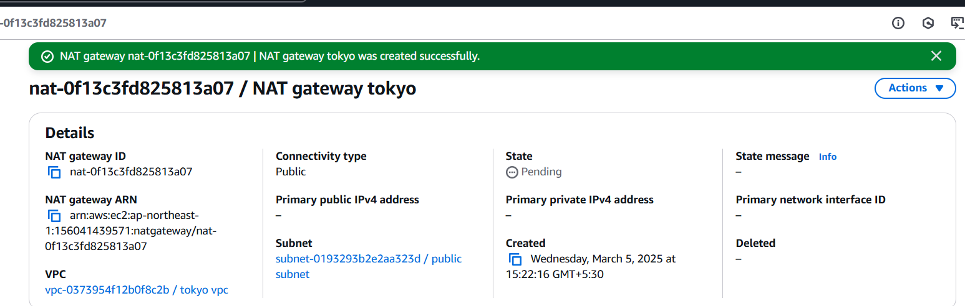
6) Create Two instances,one in public subnet and one in private subnet.
Step 1 created 1 publice ec2 and attached private subnet with vpc Tokyo
Step 2 created 1 private ec2 and attached private subnet with vpc tokyo
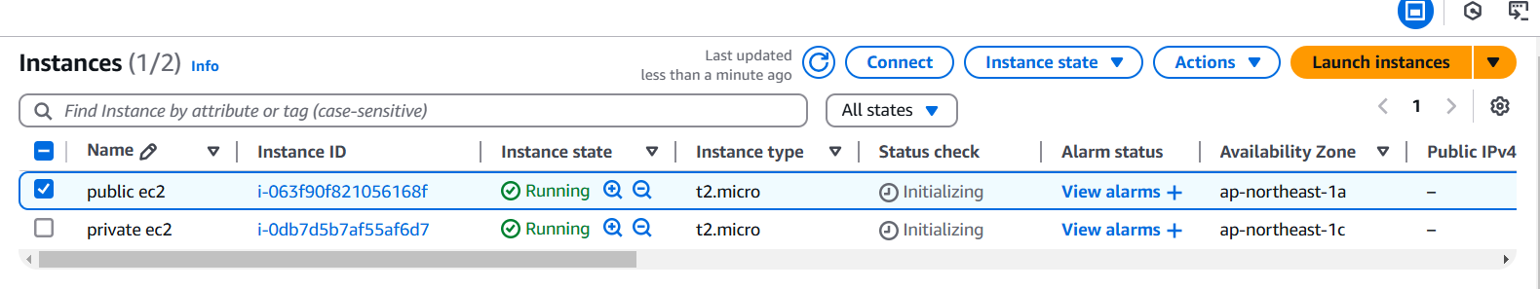
Step3 go to vpc and route table and select private subnet then edit routes
Destination 0.0.0.0 and Target NAT gateway savechanges
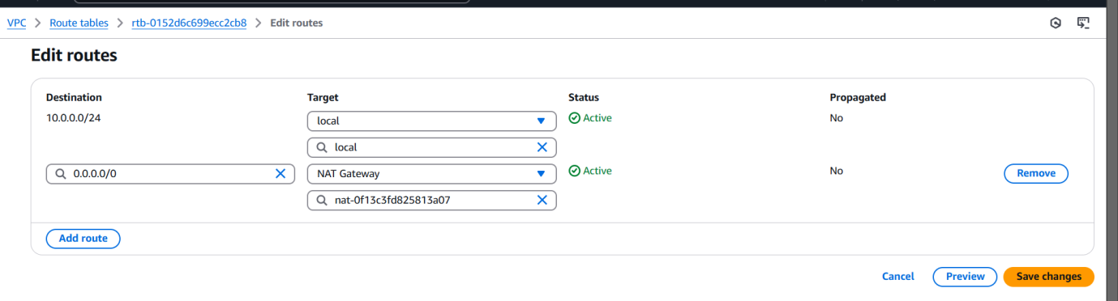

Step4 I can able to ping from pivate ec2 to google.com
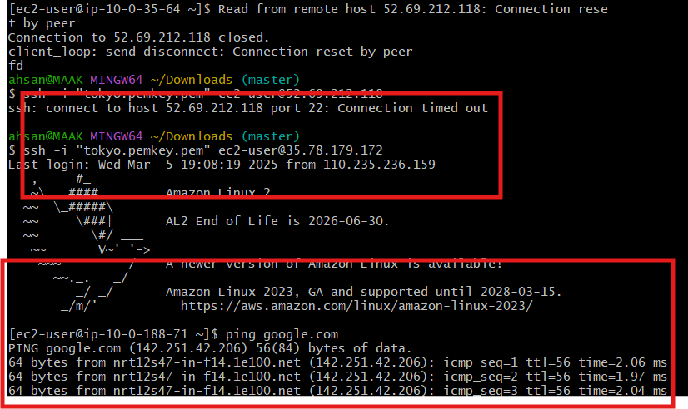
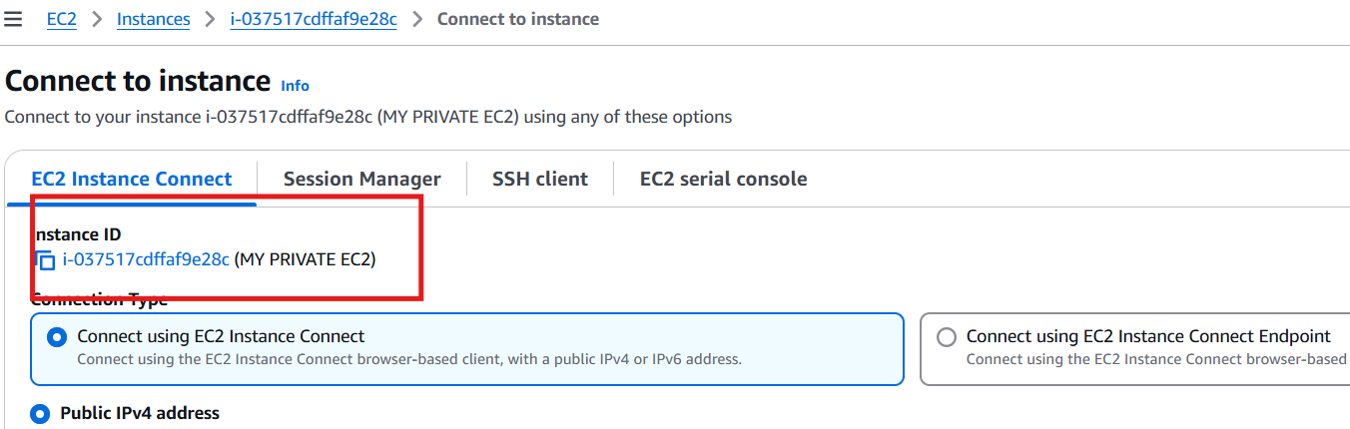
7) Deploy Apache server on both the ec2 instances with sample index.html file.
8) Create one application load balancer and attach the load balancer to both the ec2 instances.
9) Store Application load balancer logs to s3.
10) Store the vpc flow logs to cloudwtach group.
11) Create Monitoring Dashboards to monitor cpu utilization and to monitor apache service.
12) CPU utilizationis more than 70% then it should triggere Autoscaling and launch new instance.

